

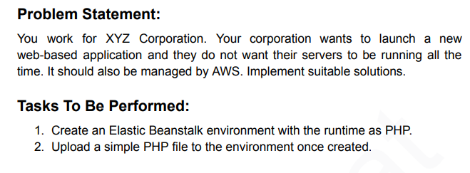

1. Creating Elastic Beanstalk Environment and Selecting Web Server Env and Given Name as Salman-Web-App

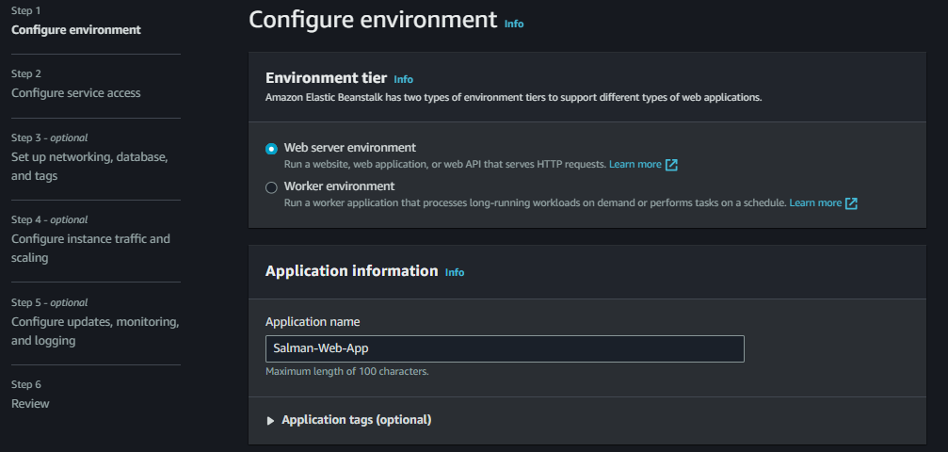

1. Its Took Environment name Automatically and I Given Domain Name and its shown Available

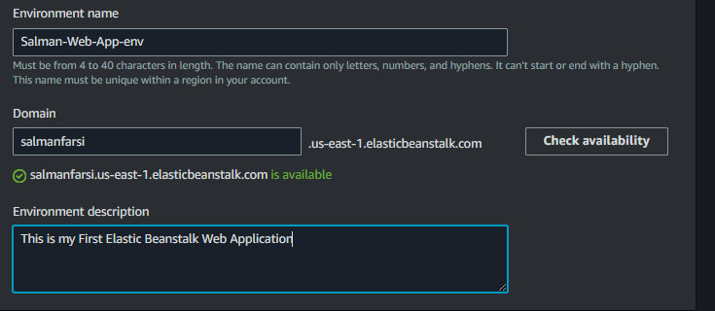

1. By Default Its Selected Managed Platform for Webserver and runtime is PHP as per the task and branch and version and Currently not uploading custom file and using sample App file .

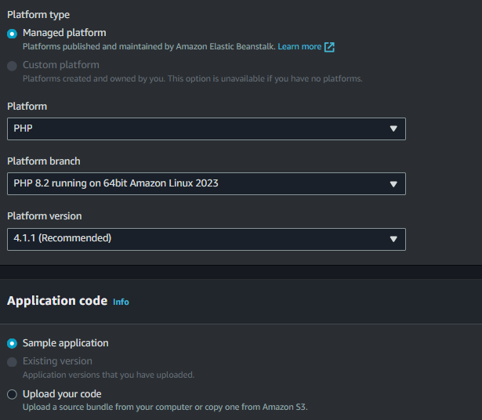

1. Choosing Free Tier eligible

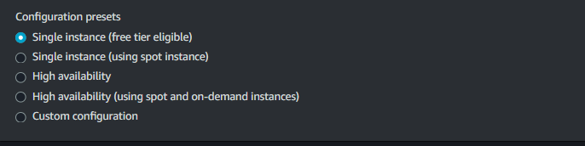

1. After That It Will Ask Role so I Came to IAM and Created EC2-AdminAccess to EC2 Instances



1. Create service role and using Existing EC2 Instance Profile which we previously Created

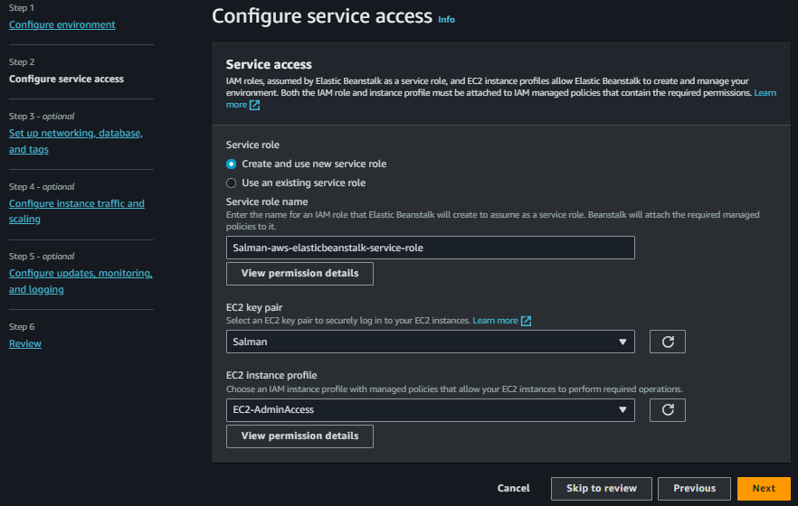

1. In Step 3 Selecting VPC

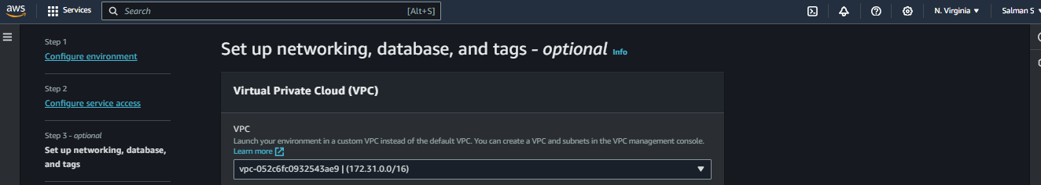

1. Currently Not Activating Public IP and Selecting All Subnets.

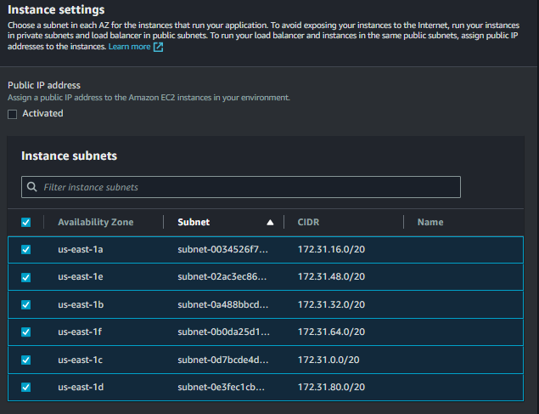

1. Not Able to Enable Database Because Its not supported to Free Tier Single Instances

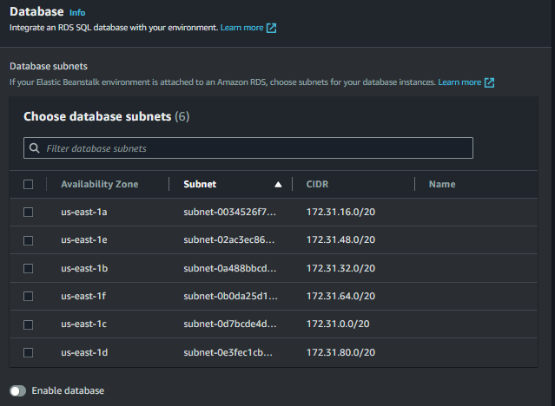

1. I Captured the Database Settings for Future Understanding Purpose

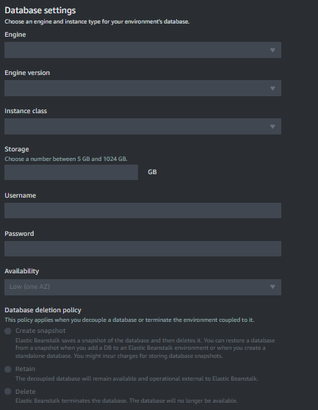

1. Root Volume is Selected by Default

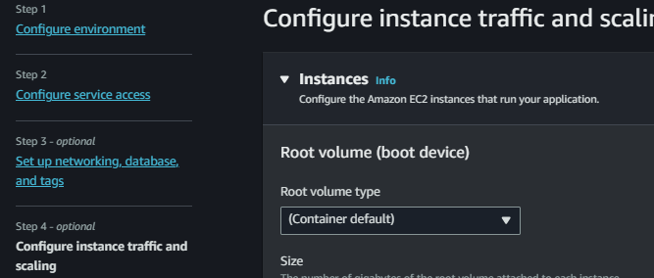

1. Default 8 GB and 100 IOPS and Throuhput 125 MiB/s for Free Tier

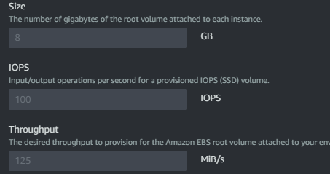

1. Monitoring Interval 5 minute once and Selected Default SG which Allowed All Traffic Defautly

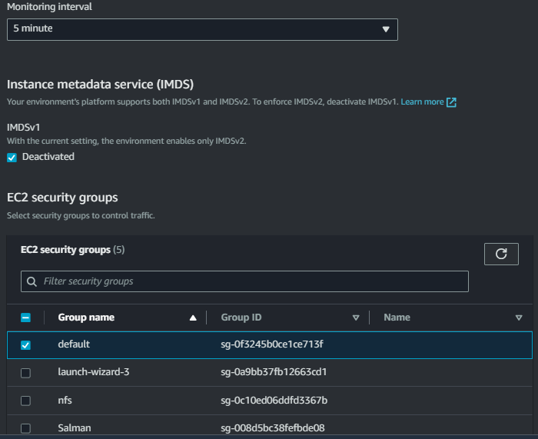

1. Configuration for Autoscaling Group Currently No Changes

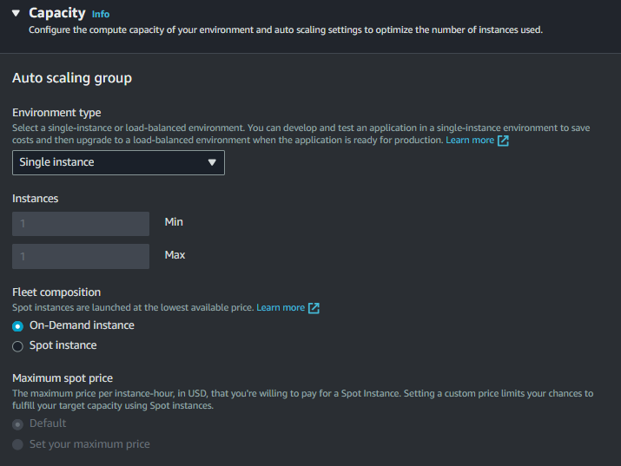

1. Using On Demand Base and Selected Architecture

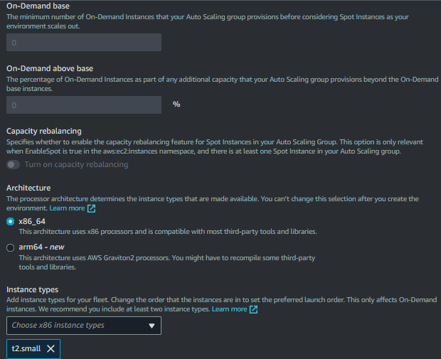

1. Free Tier AMI ID

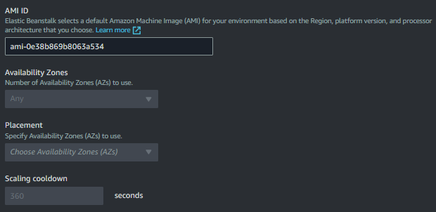

1. Monitoring Using Enhanced by default I am leaving this

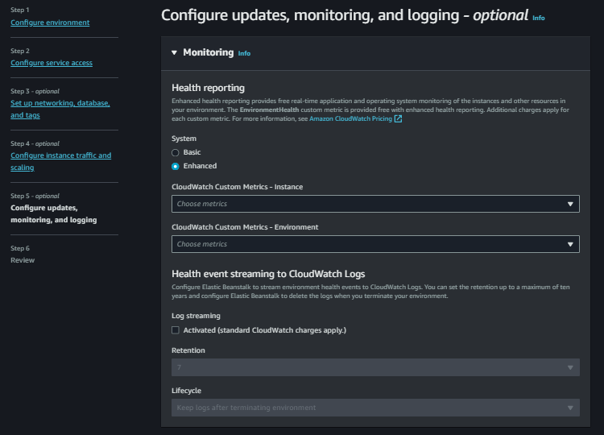

1. Managed Platform Updates it will Update Weekly Selected Day and time and we can choose Email Notifications to if we need currently not using it

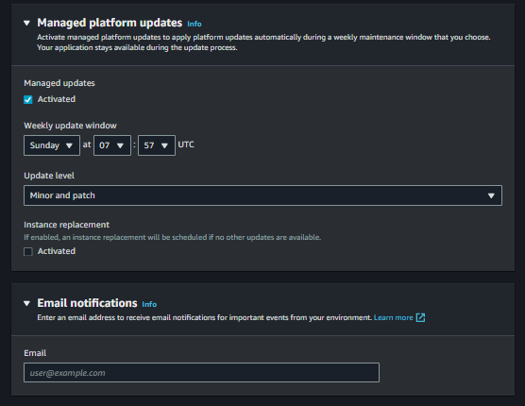

1. Rolling Updates and Deployments All At Once

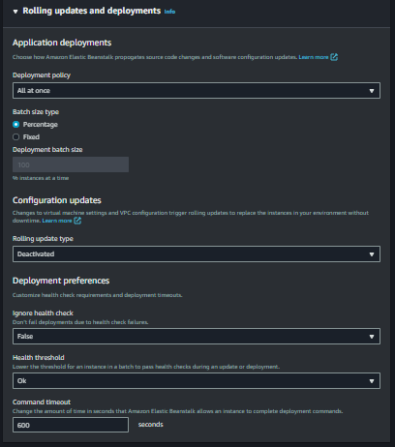

1. Using Nginx Server and memory unit and Allow URL

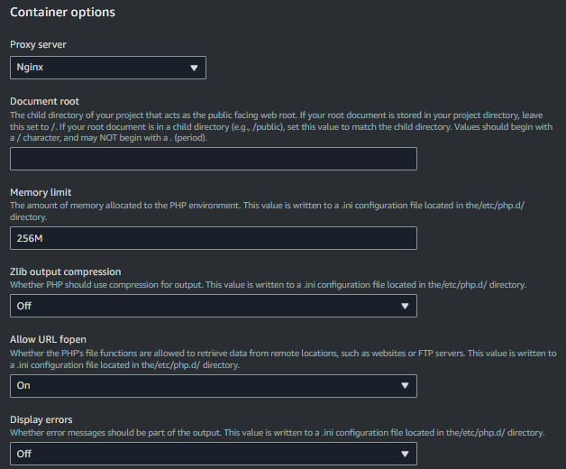

1. After Completing This all Steps Review it and Submit

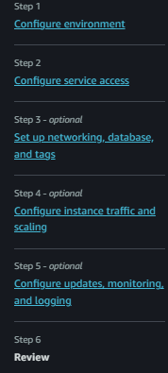

1. We Created Salman-aws-EBStalk-role so Need to give Admin Access. Go to IAM and Modify it



1. Added Admin Permission to Elasticbeanstalk environment

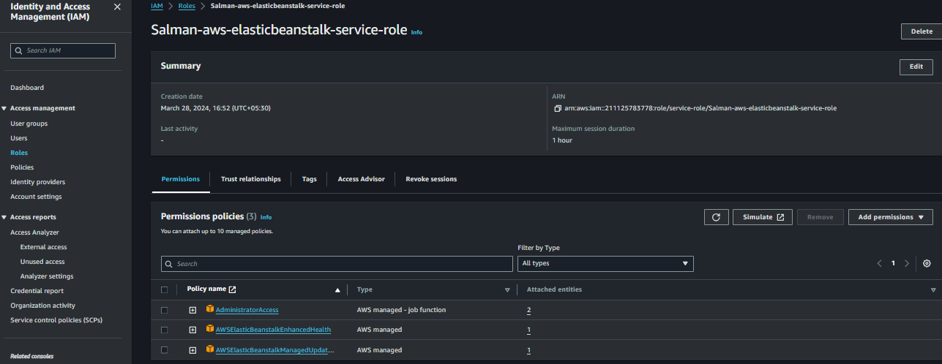

1. See Our Elastic Beanstalk Env Created Successfully and also we can see the events which are running and now Click Domain Name

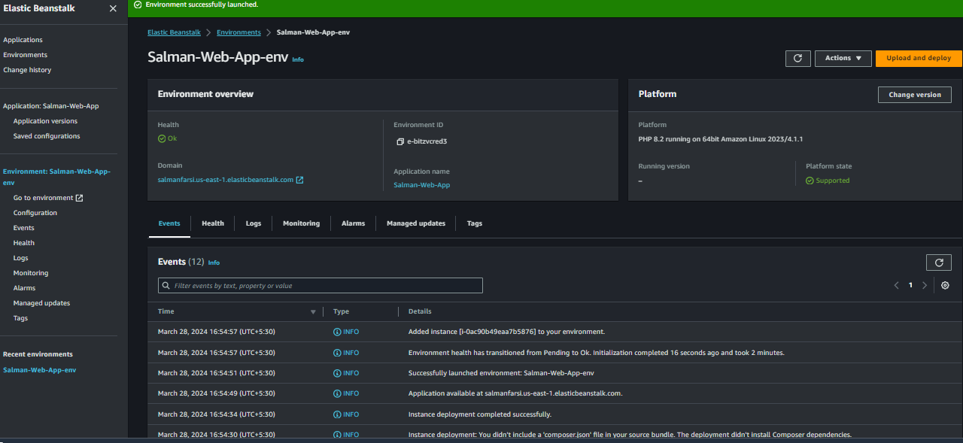

1. By Default PHP Runtime we Selected and Its showing the version name and were its running

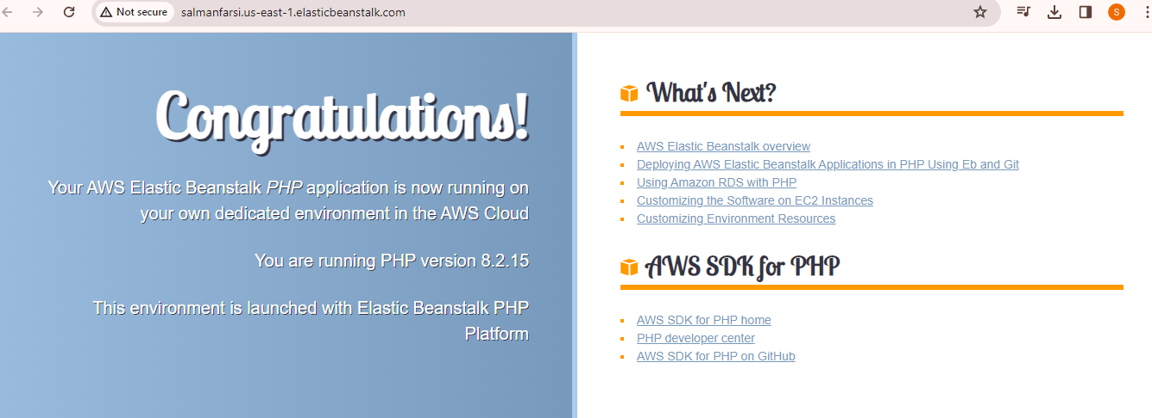

1. Now I am Using our Customize PHP Document in Zip File Format

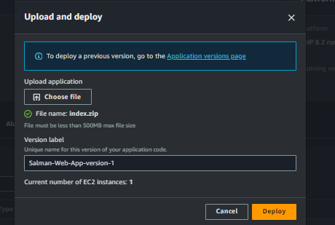

1. This Program which we Uploaded in Beanstalk and Deploying it

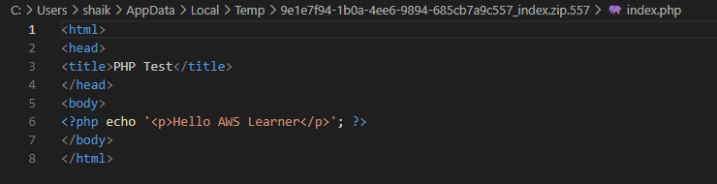

1. This Are the Events are running in Environment

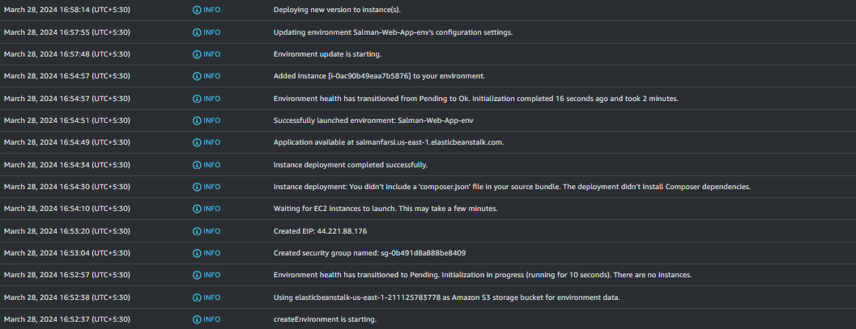

1. Refresh it, Now are able to see the Changes in the Web Application as per the Doc we uploaded



1. See Now we terminating the Environment and Its Started Terminating and Updating in the Events

